CITY OF STATHAM
AGENDA
Statham Community Center
336 Jefferson Street, Statham, GA 30666

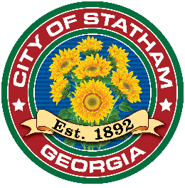
SPECIAL CALLED MEETING – February 13, 2024. 6:30 P.M.

On February 8, 2024, Mayor Debi Krause has called for a special call meeting at 6:30 P.M.
on February 13, 2024, at Statham Community Center 336 Jefferson Street, Statham GA.

INVOCATION AND PLEDGE
CALL TO ORDER
Roll Call
VOTING ITEMS
A RESOLUTION OF THE MAYOR AND CITY COUNCIL OF THE CITY OF STATHAM REQUESTING THE INTRODUCTION OF LOCAL LEGISLATION AMENDING THE CHARTER OF THE CITY OF STATHAM, GEORGIA

ADJOURN

